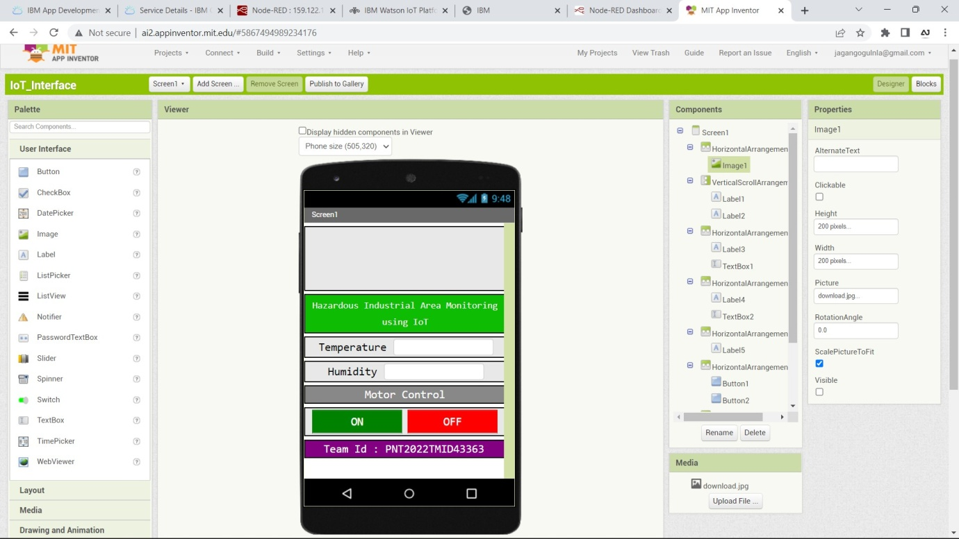**Design Your UI To Display The Temperature, Humidity**

|  |  |
| --- | --- |
| Date | 17 November 2022 |
| Team Id | PNT2022TMID46546 |
| Title | Hazardous Area Monitoring for Industrial Plant using IoT |

**In MIT App Inventor**

**In Mobile Phone**

